5.13: a) In the absence of friction, the force that the rope between the blocks exerts on block B will be the component of the weight along the direction of the incline, 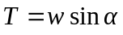. b) The tension in the upper rope will be the sum of the tension in the lower rope and the component of block A’s weight along the incline, 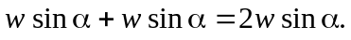 c) In each case, the normal force is d) When 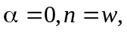 when 